SIMATS ENGINEERING
ASSESSMENT TOOL 2

COURSE NAME: CSA07 COURSE CODE: Computer Networks

COURSE OUTCOME COVERED

CO1: Apply the functions of OSI layer in enabling reliable data transmission across networks. (BL2, BL3)

Assessment Tool Weightage: 30%

Annexure A

CONCEPT MAPPING

Dr.V.PARTHIPAN

Code of Conduct:

I Sri Sayee. K (192421062) (Name / Reg No) certify that this submission is my original work and that I have adhered to the guidelines specified for this assessment.
I understand that any violation of academic integrity rules will result in disciplinary action.

Signature of the student:

ksrisayee

Annexure A

CONCEPT MAPPING

1. A partially completed concept map is given below:

Application → Presentation → ______ → Transport → Network → ______ → Physical.

Analyze the missing layers and explain how their functions are essential for reliable communication.
Ans)
Introduction
The OSI model consists of seven layers that work together to ensure reliable communication. Each layer performs a specific function, enabling efficient data transmission between network devices.
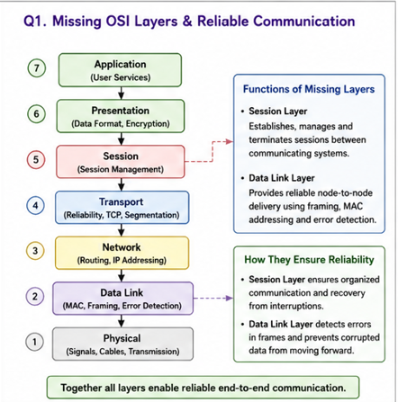
Conclusion
The Session and Data Link layers complete the OSI architecture by providing session management and reliable frame delivery. Together, all seven layers ensure secure and error-free communication.

2. Construct a concept map linking data units (Segment, Packet, Frame, Bits) with their respective OSI layers and analyze how transformation of data units supports transmission.
Ans)
Introduction
During data transmission, information is transformed into different data units as it moves through the OSI layers. This process is known as encapsulation.
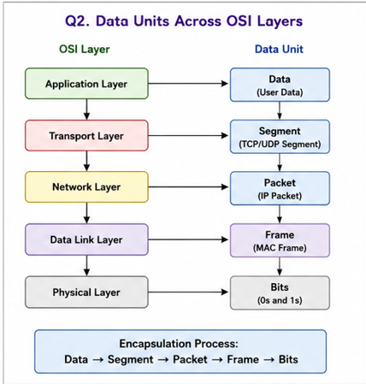
Conclusion
The transformation from Data to Segment, Packet, Frame, and Bits enables efficient transmission across networks and allows accurate reconstruction of data at the destination through decapsulation.

3.Given the concept map:
DataLink→MACAddress→LocalDelivery
Network → IP Address → Global Delivery
Explain how these relationships ensure complete data delivery across networks.
Ans)
Introduction
Successful network communication requires both MAC and IP addresses. These addresses operate at different OSI layers and perform distinct functions.
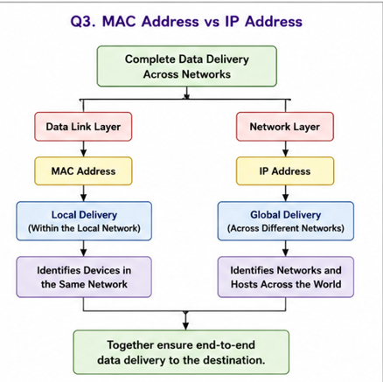
Conclusion
MAC addresses ensure local delivery within a network, while IP addresses enable communication across different networks. Together, they provide complete end-to-end data delivery.

4. A concept map shows:
ErrorControl
→DataLinkLayer→ErrorDetection
→ Transport Layer → Error Correction
Analyze how the interaction between these layers improves reliability in data transmission.
Ans)
Introduction
Reliable communication depends on detecting and correcting transmission errors. Different OSI layers contribute to maintaining data integrity.
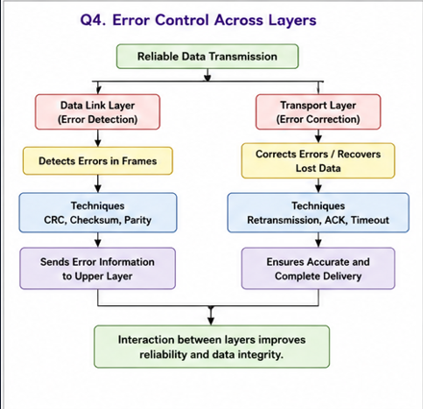
Conclusion
The Data Link layer detects transmission errors, while the Transport layer ensures reliable recovery through retransmission and error correction, improving overall communication reliability.

5. Develop a concept map for web browsing using OSI layers and analyze how failure in one layer affects the entire communication process.
Ans)
Introduction
Web browsing involves all seven OSI layers working together to establish communication between the user and the web server
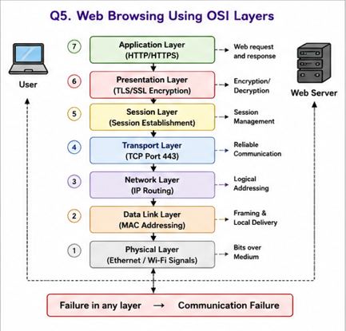
Conclusion
Each OSI layer has a specific responsibility, and failure in any layer interrupts the communication process. Therefore, all layers must function correctly for successful web browsing.

6. A network issue is represented in the concept map:
Physical ✔ → Data Link ✔ → Network ✖ → Transport ✖ → Application ✖
Analyze the problem and explain how the concept map helps in troubleshooting.
Ans)
Introduction
Network troubleshooting becomes easier when communication problems are analyzed according to the OSI model. Each layer can be checked systematically to identify failures.
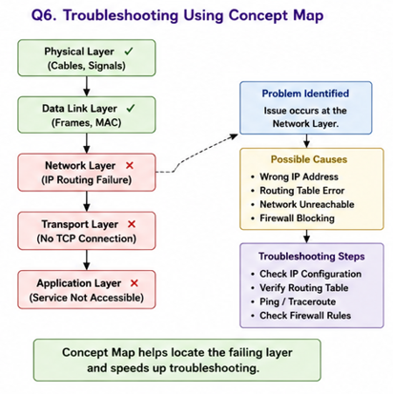
Conclusion
Since the Physical and Data Link layers are functioning correctly, the issue originates at the Network layer. Using the OSI model helps isolate faults quickly and restore normal communication.

RUBRICS FOR CALCULATION

Criteria | Weightage (%) | Level 4 (Exemplary) | Level 3 (Proficient) | Level 2 (Developing) | Level 1 (Beginning)
Concept Identification | 20% | Accurately identifies all relevant OSI layers, concepts, and relationships | Identifies most concepts with minor omissions | Identifies limited concepts; some inaccuracies | Unable to identify key concepts correctly
Concept Mapping Structure | 25% | Constructs a clear, logical, and well-organized concept map with proper hierarchy and connections | Concept map is mostly clear with minor structural issues | Concept map lacks clarity, organization, or proper flow | No clear structure or incorrect mapping
Linking & Relationships | 20% | Clearly establishes correct relationships between layers, functions, and processes | Relationships are mostly correct with minor errors | Limited or partially correct relationships | Incorrect or missing relationships
Application & Analysis | 20% | Effectively applies concepts to explain processes (e.g., encapsulation, error control) with strong reasoning | The application is correct but lacks depth in analysis | Basic application with weak explanation | Unable to apply concepts correctly
Explanation & Clarity | 15% | Provides a clear, concise, and well-structured explanation supporting the concept map | Explanation is understandable with minor gaps | Explanation is unclear or incomplete | No clear or meaningful explanation

